2.1 I can prepare content for my web pages so that it is ready for editing and formatting

The steps I have taken to ensure my website is functioning and shows images and texts and a video properly are:

**Images:**

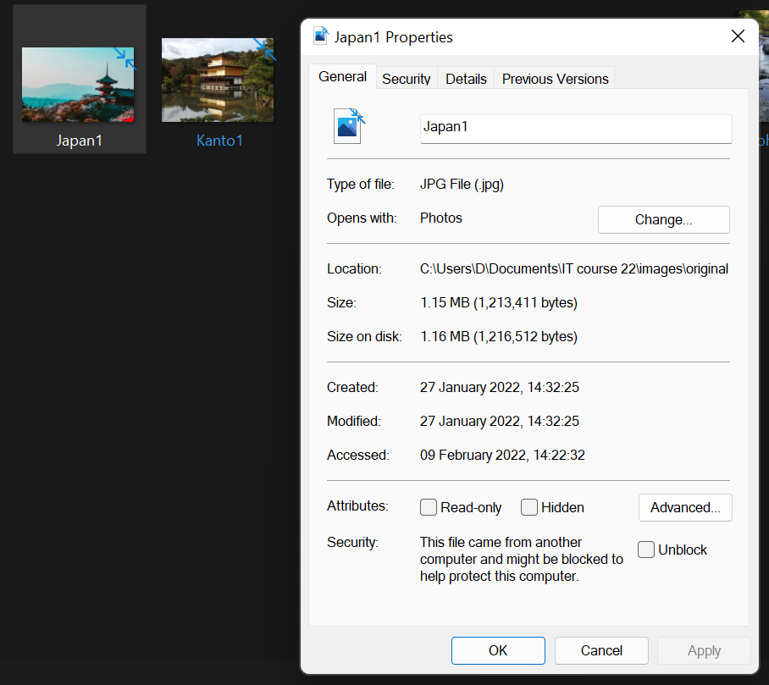

[The above photo shows the properties for the file type and it is a JPG which is the file type I want]

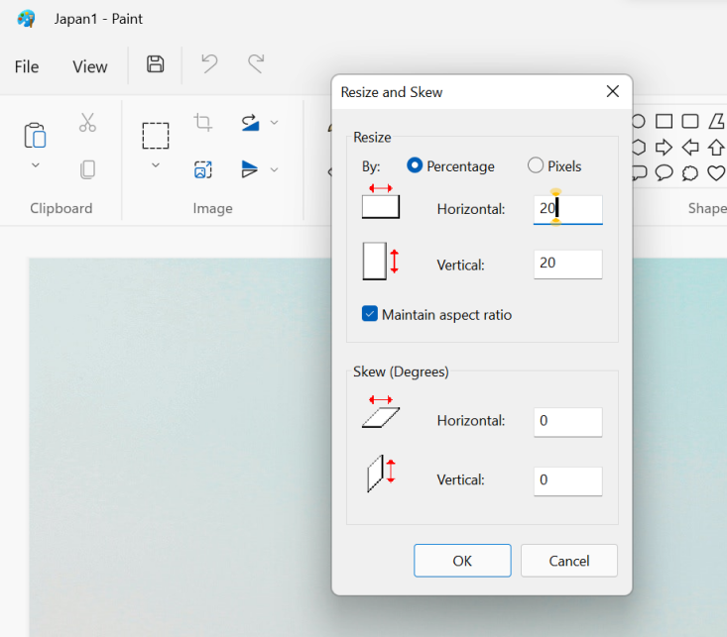

[The above photo shows that I have put the photo into Paint and played around with the resizing until I am happy with the size]

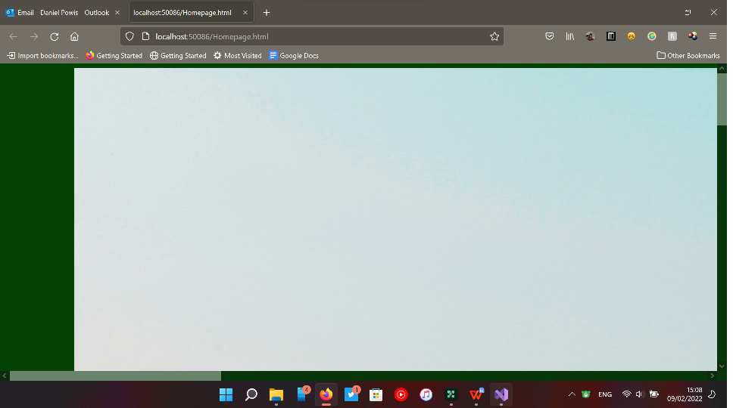

[The above photo shows the image before resizing]



[The above photo shows the image placed on the website after]

**Text:**

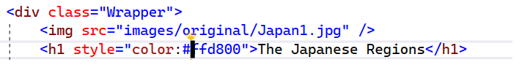

[The above image shows that I have applied colour code #ffd800 which is yellow to my header on the home page]

**Video:**

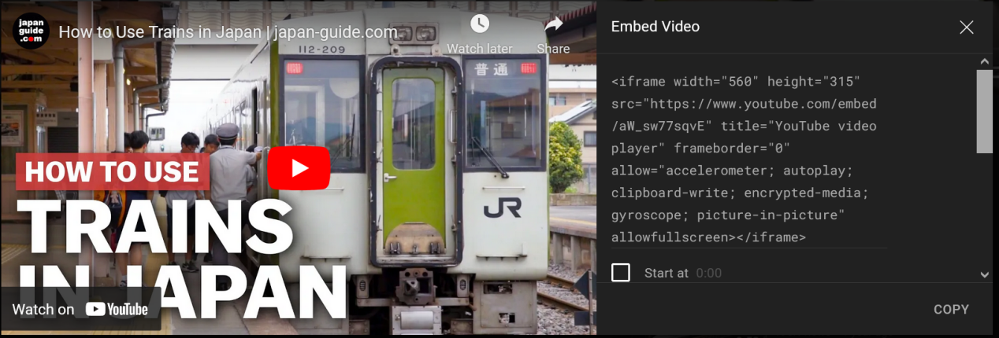

[The above image shows that I have pressed the ‘share - embed’ buttons to get the embed code to put on my Visual studio]



[The above photo shows that I have now put the embed code onto visual studio]



[The above photo shows that the video is on my web page successfully]